PROPOSAL
11-11-14

ROTARY PARK ON THE GREENBELT
or, "Government Island/Fort Boise Interpretive Park"
November 2014
Boise Metro Rotary Club, Boise Centennial Rotary Club, Eagle/Garden Rotary Club
John Biggs, Boise Metro, Committee Chair
369-0244 biggs81@gmail.com

Background
About 6 months ago, John Biggs contacted Jerry Pugh at Boise City Parks and Rec to see if there was any project in the parks that Boise Metro Rotary might adopt. Jerry explained the new .8 mile section of Greenbelt to be built in 2015, from Joe's Crabshack to Ann Morrison Park, and suggested several ideas we might be interested in, including the notion of a rest area. We walked the proposed route and looked at several possible locations. Jerry explained that funding for the project was in place but it did not include funds for a rest area or other amenities, which they would like to include.
Knowing that Boise Metro and other clubs in the valley had done Greenbelt projects in the past, and that his club had many cyclists and Greenbelt fans, John proposed the rest area idea to Metro. It was enthusiastically received. At some point, it was suggested that this project might be too big for Boise Metro and we might invite Centennial and Eagle/Garden City, both small clubs, to join the project.
The proposal, in very general terms, was presented to the other two clubs who also endorsed the idea and voted to proceed. No commitments had been made, just an expression of interest.
On September 25, John met with Toby Norton from Boise Parks and Rec and Brandi Burns and Terri Schorzman from the city History Department to find out more about the monument. After they did some research about its history, they were excited at the idea of making it the focal point of our rest area. (So, lets call this the "Government Island or Fort Boise Monument Interpretive Center"!)
A steering committee met for the first time on October 30, 2014, to review the proposal. The project was enthusiastically endorsed at that meeting and it was decided to finalize the proposal document (this document) and, after final review by the committee members, forward it to the clubs for final approval.
(In attendance at that meeting were: Boise Metro - J Biggs, M Barker, J Larsen; Eagle/Garden City - G DeLaveaga, Dick Norquist; Centennial was not represented.)

Elements and Features
The focus of the area will be the Sons and Daughters monument. Keep in mind that this "rest area" will not be a destination or gathering area. The area is quite noisy from the adjacent highways and is not accessible by car. Rather, people might stop to linger, check out the monument, catch their breath, pump up their tires and continue on. The rest area might feature these elements:
- Seating area (benches, sitting wall)
- Pioneer monument
- Bike Repair stand
- Drinking fountain for people and dogs
- 3 panel Interpretive Sign re: the monument, Greenbelt etiquette, Rotary Clubs
- Landscaping (the site has irrigation water)
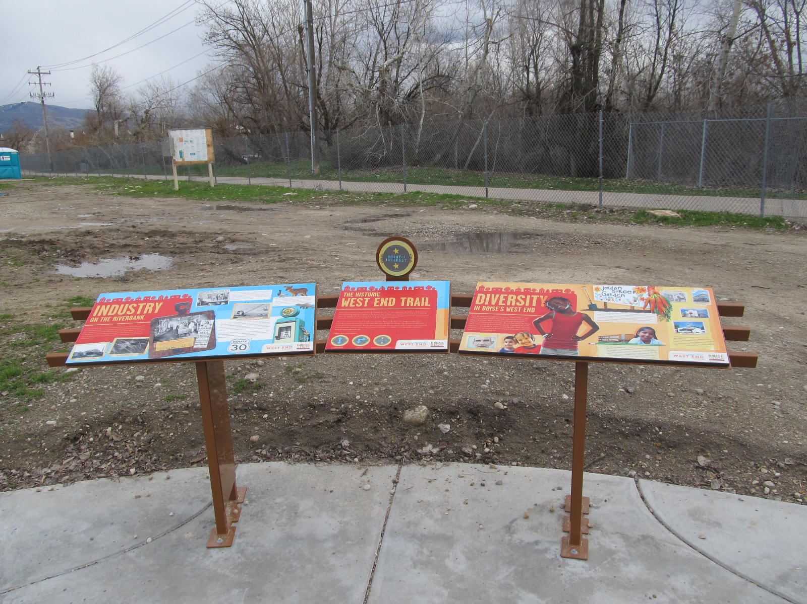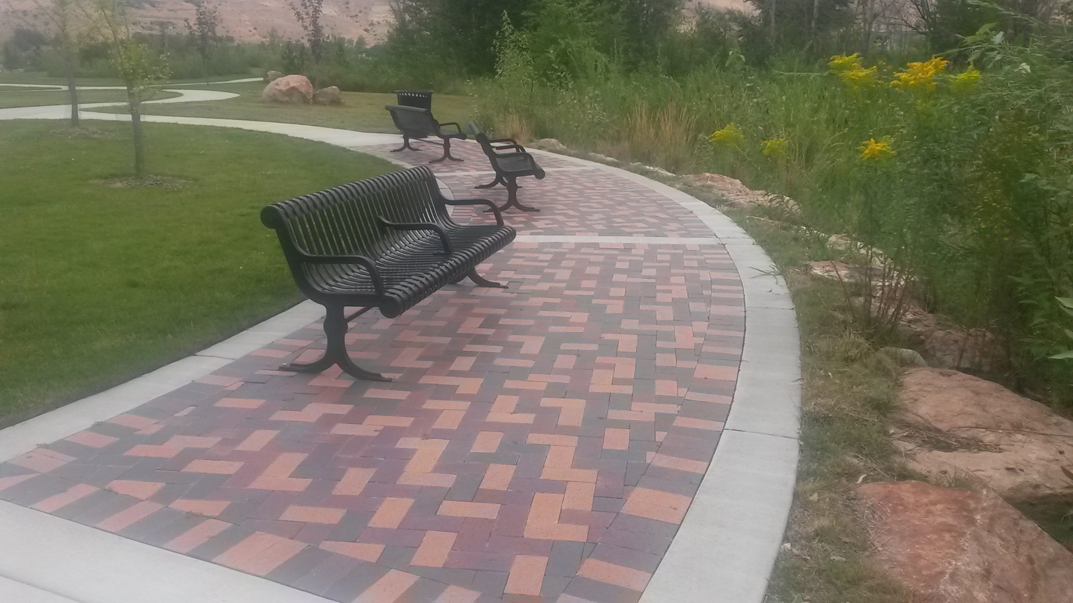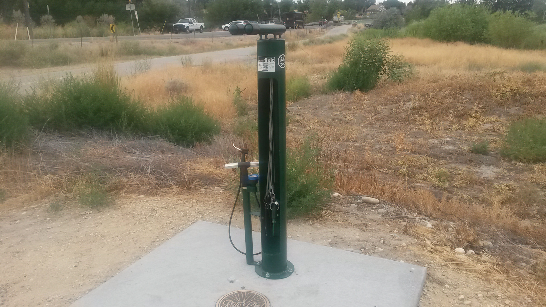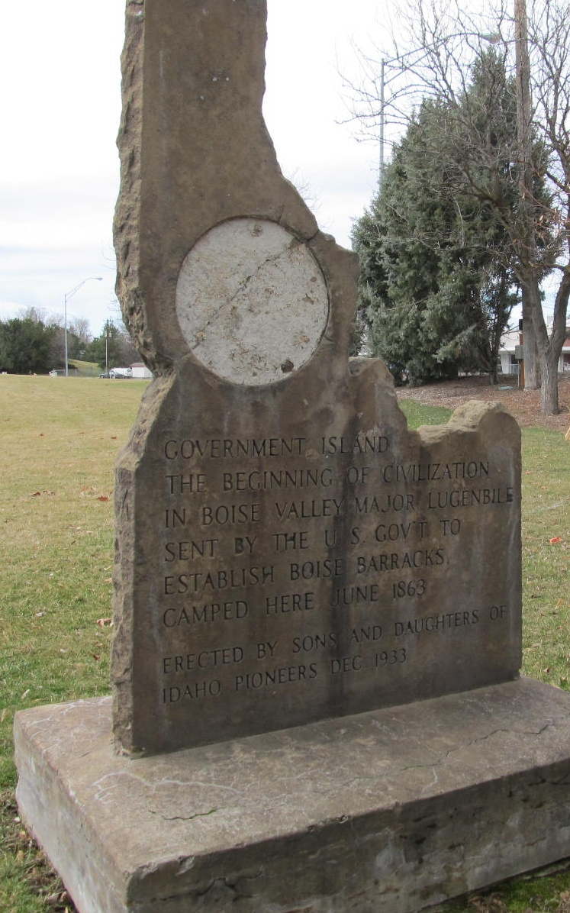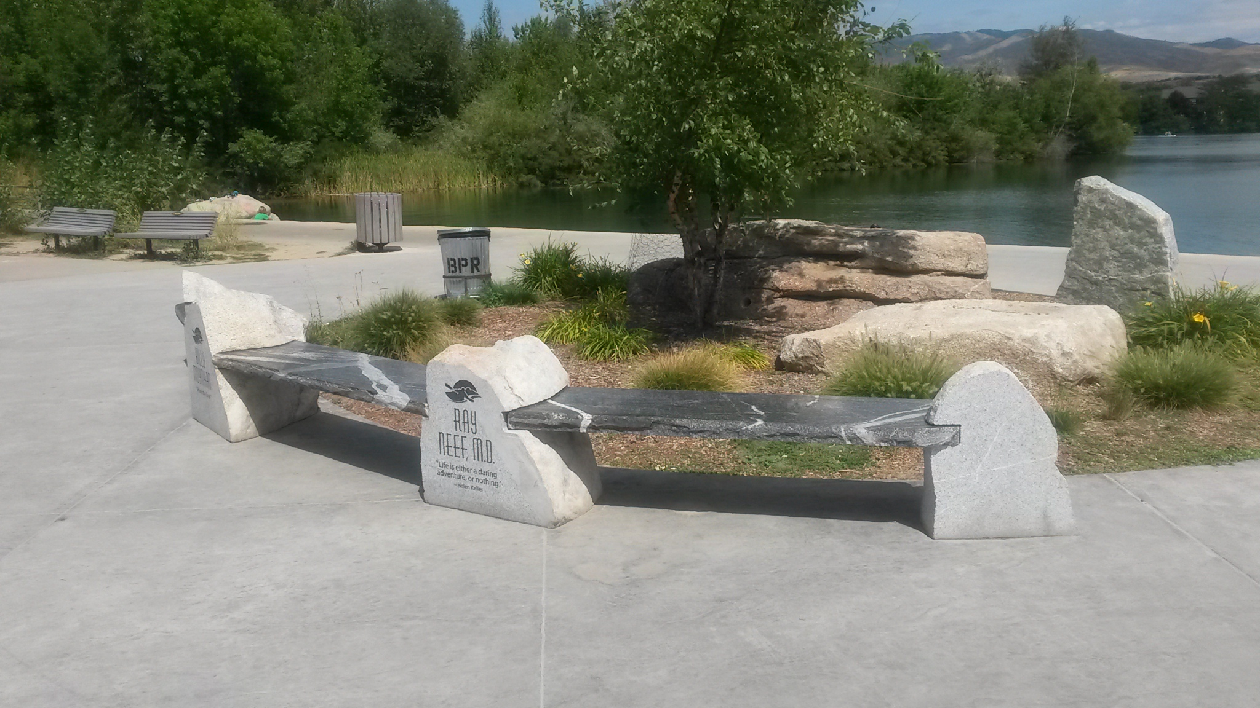

- landscaping (the site has water available)
Examples of elements found along the Greenbelt

Time Line
We are told the construction will start in the summer of 2015. We would anticipate that the new section would actually be open for use in the late spring/early summer of 2016. (Remember, there are two tunnels involved!) We would propose constructing the rest area in the summer of 2017, giving us about 2.5 years to design and fundraise. Because of unknown engineering issues at this point, we probably could not finalize our designs until the trail was almost complete. (We may be able to construct our rest area during the greenbelt construction and enjoy some cost savings, which would accelerate our fund raising effort)
We would begin our fundraising campaign next spring, about the time of the "groundbreaking" of the trail, which is sure to draw some publicity.

Cost Estimates
There too many unknowns to accurately estimate the cost of the project. Access to the site from the Greenbelt could be complicated by elevation issues which we won't know until the trail is finally excavated. We'll also have to negotiate with the city as to the cost of rehabilitating and moving the monument and their participation in the interpretive sign. We will be able to estimate hard costs like benches ($1,000) , repair stand ($2,500), bricks ($20) , etc. Hopefully, we will have access to in-kind support which cannot be identified at this time. For example, Rotarian labor, friends with excavators, donated shrubs, etc.
Therefore, we are proposing that we set a goal of $30,000, to be raised over the next 2.5 years, to be our "war chest". We will ask the City engineers to confirm that we should be able to complete our project with that amount.
There may be opportunity to negotiate with the city and "dovetail" on their project.

Fund Raising Ideas
Start fundraising efforts next spring when the construction actually starts. Goal would be reach $30,000 by April 1, 2017 (or before?)
Some ideas:
- Sell bricks/pavers with names engraved (Engraved 4x8 bricks cost about $20. Sell for $75??)
- Fundraising "event" to be held every spring, maybe in partnership with Riverside Hotel or Joe's Crabshack (could be annual event, with funds dedicated to Greenbelt improvements) Let's get creative!
- Sponsorships (bike repair stand, benches, interpretive sign, trees)
- Kickstarter/crowd funding
- Grants - District 5400 Block Grants, Greater Boise Rotary Foundation, other Rotary clubs and others

We will stress with the clubs that they will not be asked to raise money on their own. We'll design our fundraising efforts jointly and work together to achieve the goal.

Next Steps
- Finalize this document, get the three Rotary Clubs to "sign off"
- Create some artist renderings
- Meet with Parks and Rec / City represenatives to get their input
- Find out how to officially make the proposal to the city
- Form two committees - Fund Raising and Design-Build

J Biggs 11-11-14

