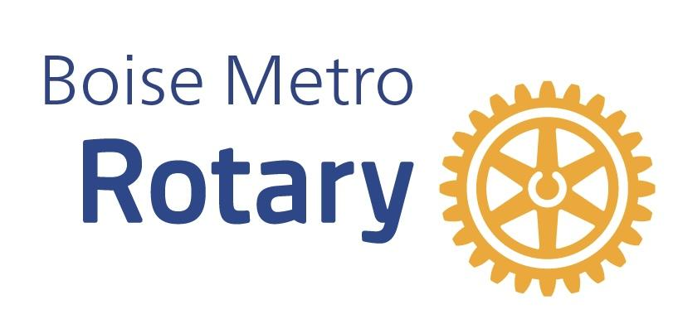

Boise Metro Rotary Club
Test Drive Rotary Program

Boise Metro Rotary recognizes that young and talented community contributors are looking for avenues to engage within their communities and possibly with civic organizations. Members of Boise Metro Rotary understand that engaging as a member of a civic organization is a commitment of time, talent and treasure. The Club wants to ensure that new members are a mutual fit for the Club culture, Club focus and mission to ensure a long term relationship. Boise Metro Rotary Club has developed the “Test Drive Rotary” program for new, prospective members to better understand what it means to be a Rotarian and a member of Boise Metro Rotary.

Test Drive Rotary Outline:
- Boise Metro will pay for Test Drive Participant lunches during the 8 week Test Drive Period
- The Boise Metro Rotary Membership Committee will assign a mentor (Club Member) during the Test Drive Period
- Boise Metro Rotary will have no more than 5 Test Drive Participants at one time

Test Drive Rotary Participant Requirements:
- Complete a membership application, indicating Test Drive
- Not a previous member of a Rotary club
- Attend 7 out of 8 weekly meetings during Test Drive Period (make-ups allowed)
- Test Drive Participants will be encouraged to engage in the following club functions:
  - Service project
  - Fellowship event
  - Board meeting
  - Serve as a greeter at a Club meeting

After Test Drive Period:
- Test Drive Participant will meet with the Club President, Membership Chair or Mentor to discuss their experience and determine if they would like to become a member of Boise Metro Rotary.

